Butler Auctions Present’s
The Estate Sale of Harold Nadler
Wednesday July 17th at the Saginaw Masonic Temple @10AM
(Building is Air Conditioned)
!(Due to limited parking at the residents home the sale will be held at the Masonic)!
DIRECTIONS: Take M84 South to Tittabawassee, East on Tittabawassee, South on Center
Address: 2655 N Center Rd, Saginaw, MI
! Watch for Butler Auction Signs !
Listed Items for Sale At The Auction
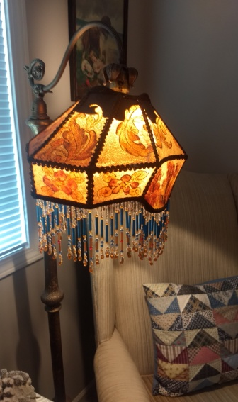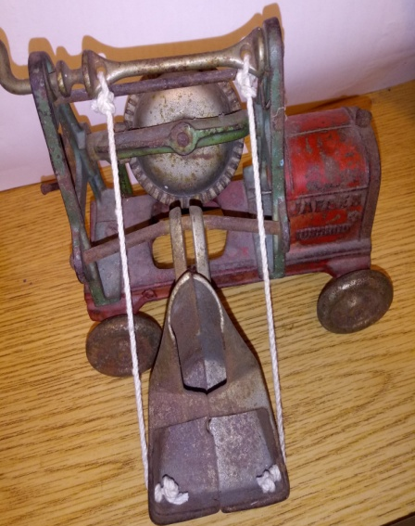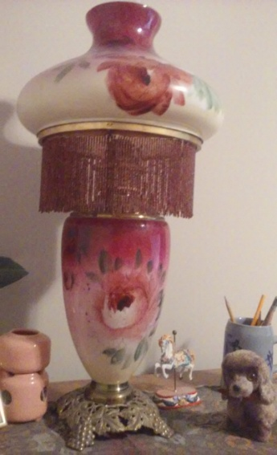
Furniture: Tiger Wood Bedroom Set, Cedar Chest, Childs Rocker, Hide a Bed, Metal Stand end Table, Entertainment Center, Grandfather Clock, Office Desk, Side Cupboard, Bookcases, Magazine Rack, Vintage Wooden Highchair, Kitchen Table w/ Chairs, Bench, Tiffany Style Lighting Fixtures, Oak Table w/ 4 chairs, Pine Table w/ chairs, Multiple Lamps, Victorian Table w/ marble top, Duncan Phyfe table and chairs, Colonial Style Secretary Desk; Glass Top End Table and much, much more!
Vintage Toys: Kenton JAEGAR (1939 Cement Mixer, (?) Steiff bear, Metal Military Soldier
Guns: M66 Super Single Shot Ithaca 12 Gauge 3in Mag, Lever Action; made of Daisy out of Scotland #60, 77 Pellet Gun; 22 Hopkins and Allen Double Action Revolver for Parts; Daisy BB tin
Electronics: Sanyo 32” LCP HDTV, Sanyo LCPHD7U 19”, 15” LCD HDTV, 19” Insignia HDTV, 42” LG TV, 26” Sanyo HDTV, LCD World Traveler, AM/ FM Radio, VCR
Appliances: Kenmore Washer & Gas Dryer, Dehumidifier, Fans, Vacuum’s (3), Shop Vacs, Irons, Microwaves, Small Refrigerator, Bissell Carpet Extractor, Eureka Vacuum, Sharp Vacuum, Microwave, Toaster Oven, Cordless Phones, Sears Wet Dry Vacuum, Electric Blower, Shoe Buffer
Medals/Pins: 1996 Olympic games pin set; Centennial 1896-1996 Olympic Games Collection, Military Metals
Kitchen Items: KRUPP Waffle Maker, KRUPP Toaster Oven, Panasonic Microwave, Toaster, Blender, Assortment of Pots and Pans, Silverware, Miscellaneous Cooking Utensils, Mixing Bowls, Plates, Cooks Essential Pots & Pans
Collectables: Vintage Spice Cans, Whiskey Bottle w/ Label, Ladies Fans w/ Advertising on they back (early 1900’s possibly), Yard Sticks, Hummel Chimney Sweep, MURANO Glassware, Child’s Commode & Ceramic Pot, Victorian Style Frame w/ picture, Victorian Lamp (2), Racing Patches, Wash Board, Morton Salt Thermometer, Sad Irons, Matchbox Match Holder, A yearbook of Railroad Information 1915 Ed, Brady Sausage and Judd, Inc. Insurance Scale (?)
Tools: Craftsmen 7” Circular Saw, Sears 18” Electric Drill, Battery Charger, Wheel Barrow, Stepstool, Paint Brushes, Screw Drivers, Foldable Ladder, Shovels, Steam fast Kitchen and Bath steam Cleaner, Household Toolset, Roof rake, Extension Cords, Planer, 5HP Craftsman Generator, Shop Vacs (2), Craftsman 1/3 HP Bench Grinder, Compressor 100 PSI, Misc. Screws and nails and more
Coins/Currency: State of Michigan proof set (3); Proof set 100 years of Historic U.S. Nickels, Complete presidents coin collection, 24K Gold Quarters 2001& 2002, 24K Gold Quarters 2003 & 2004; Commemorative Quarter of the U.S.
XMAS Items: Tree, Holiday Santa, Snowman, Figural Glass Light Bulb, Bubble Light, Vintage Ornaments, X-MAS Bulbs, Shiny Bright Atomic Bells, Christmas Lights
Linens: Crocheted Table Cloth, Bedding, Towels, Quilts, Chair Pads
Yard Items: Planter, Statuary Bunny, pagoda, Statue of David
Wooden Boxes: Wilson Cheese Company, Potarino, Ammunition Box
Books: Encyclopedias, Mother Goose Copyright 1915, Songbook Vintage
Miscellaneous: Canning Jars, wooden Barrel, Cleaning Supplies, Spray Paint, Thermos, Lunch Box, Paint, Yard Care Items (sprays, plant food), Household Cleaners, Records, Rugs AND SO MUCH MORE!!!!!
We Accept Visa, Mastercard, American express, 3% Charge w/ Credit Cards, We Accept Valid Checks as well!

