Moving Estate Sale of Lynette Louchart-Kiefer
August 4th @10AM at 13530 Dixie Highway, Birch Run, MI
Directions: Head southeast on I-75 S, Take Exit136 for M-54/M-83 towards Birch Run, Use the left 2 Lanes to turn left onto M-54 s/M-83/ Main St, Turn right onto Dixie Highway
Watch For Butler Auction Signs
Fod and Restroom Available.
Terms: Cash, Visa, Master, Discover ($50. min) or good Michigan Check w/proper I.D. All goods sold as-is, with no guarantees or warranties. Sales force acting as agents only and are not responsible for accidents or goods after sold. Nothing removed until settled for. Announcements made day of sale take precedence over printed matter.
Following Listed Sales Items
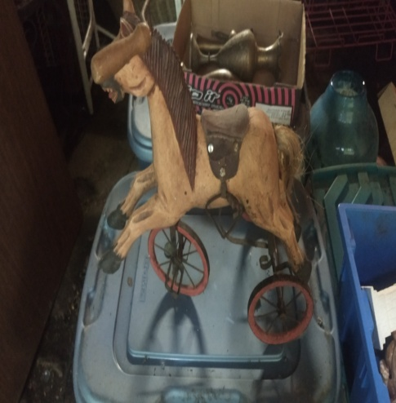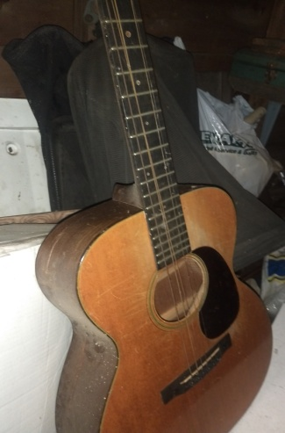
Musical Instruments: Guitar 1937 Martin Model 000-18 (needs repairs)
Furniture: Dressers, Table and chairs, Medicine Cabinet, Clothing Storage Racks, Vintage Chopping Block, Vegetable Bin, Bamboo Bookcase, Kids Cupboard
Kitchen: Rooster Canister Sets, Bowls, Various Mixing Bowls, Pots and Pans, Ice Cola Beverage Dispenser, Copper Molds, Blue Spackle Mixing Bowls
Books: Various Collections
Crafts: Mixture of Items
Tools: Champion Heavy Duty 5 Speed Drill, Delta Scroll Saw, Clamps, Saw Table, Various Hand Tool, Stanley Tool Box
Appliances: Washer & Dryer
Yard Items: Series 1000 CUB CADET Lawn Mower, Decorative Field Stone, Bird Bath, Canopy Frame w/ Benches, Small Wrought Iron, Table Top Green Base House, Plant Stands, Metal Headboard & Footboard used for Garden Décor, Milk Jug Metal, Grill, Propane Cook top Coleman, Playhouse, Dog House, Wind Chimes, Triangle, Yard Candle
Boat: Star Craft Aluminum Boat
Jewelry: Costume Jewelry
Kids Items: Radio Flyer Tricycles, Rocking Horse, Metal Doll Furniture, Maple Log Cabin, Doll House
Collectables: Wooden Pop Boxes (Pepsi/Popshop), Pop Bottles, Horse w/ Wheels, Serving Tray, Glassware, Chalk Ware Parrot, Oil Lamps
Vintage Kitchen Utensil/ Tins: J & B, Cracker Jacks, Farmer Peets Shorten, Ritz, Jays, New Era Potato Chips, Heavenly Coffee, Alaskan Carving, Wooden Flying Machine, Whirly Gig
Wall Décor: Various Pictures
Electronics: Mickey Mouse TV, Fax machine
Terms:
Cash, Visa, Master, Discover ( with 3% charge) or good Michigan Check w/proper I.D. All goods sold as-is, with no guarantees or warranties. Sales force acting as agents only and are not responsible for accidents or goods after sold. Nothing removed until settled for. Announcements made day of sale take precedence over printed matter.
ood and Restroom Available.
Terms:
Cash, Visa, Master, Discover ($50. min) or good Michigan Check w/proper I.D. All goods sold as-is, with no guarantees or warranties. Sales force acting as agents only and are not responsible for accidents or goods after sold. Nothing removed until settled for. Announcements made day of sale take precedence over printed matter.

(For More Information Look on AuctionZip.com @Butler Auctions)

