Estate Sale of Mary & Lavern Creslinski
7550 w. Birch Run Rd
September 15th, @ 10AM
Directions: Head south on I-75 S, Take Exit 144 towards Dixie Highway, Turn right onto Dixie Highway, Turn left onto Fayette St/Fort Rd, Turn right onto Curtis Rd, Turn Left onto M-13 S, Slight right onto E Rd, Merge onto W Verne Rd, Slight left, Continue Straight onto Bueche Rd. Turn right onto Fergus Rd, Turn left onto Gasper Rd, Turn right onto W Birch Run Rd
Watch For Butler Auction Signs
Jewelry: 14 KT White Gold Rose cut Diamond Ring, 14 KT European Diamond Earrings, Dollar Watches, Imitation Pearls, Costume Jewelry, Men’s & Women’s Watches, Jewelry Boxes, Illinois Pocket Watch
Dealer Promo Cars: 1949 Ford, 1965 Ford, 1964 T Bird, 1967 Plymouth, 1966 Ford Galaxy, Mustang (No Date)
Coins/ Currency: Silver Certificates, Mercury Dimes, Nickels, Liberty Peace Dollars ( +14 ), Morgan Dollars ( +14 ), Fifty Cent Pieces.
Toys: Tonka, Ertl, John Deere, Ladies Western Flyer Bike, Bobsled, Old Smoky Locomotive
Furniture: Cedar Cabinet, Drop leaf Table, Saw Pine Cabinet, Dresser, Buffet Cabinet, Secretary Desk, Formica Vintage 1950’s Table, Gone With The Wind Style Oil Lamp
Advertising: Farmer Peets Lard Cans, 1981 Smith Douglas Cloth Calendar, Banner Brewing Bottle, North American Hunting Club Belt Buckle, Pioneer Sugar Tin, Calendars For Chesaning Business and other Chesaning & Charles Items
Glassware/ Pottery: John Deere Cookie jar, Cobalt & Blue Glassware, Vintage Yellow Glass, Nescafe, China 12 Piece Place Setting W/ Serving Pieces Knowles
Memorabilia: 1947 Tigers Baseball (Team Signed), Post Cards (MI, Various State Books, Embossed), 1942 St. Charles Baseball Team Sweater, Bank Bags, Winchester Poster, Jack Rabbit Bean Collectables, 1985 Saginaw News Printer Plates, Smith & Douglas
Kitchen: Wagner ware Cast Aluminum Roaster, Bread Pans, Enamelware Roaster, Nesting Pyrex Bowls Primary Colors, Grisswald Cast iron Griddle, Canner, White Enamel Canner, Sunbeam Mix Master, Cookie Cutters, Chef Choice Knife Sharpener, Roger and Company Silverware w/ Bill of Sale 1949, Sesame Seed/ Nutmeg Vintage Grinder
Holiday: Halloween Items, Ceramic Christmas tree
Tools: Grinder, Work Bench, Hand Saws, Miscellaneous Hand Tools
Appliances: Older Refrigerators (2 )
Military: U.S. Army Ladies Compact, Army Cigarette Case
Maps: 1963 U.P. County Maps, 1953 County Maps
Miscellaneous: Ideal Wash Tubs, Vintage Egg Scale, Police Badge w/ Hand Cuffs, Smith & Wesson Military Police Revolver Box Only, 1900’s Prayer Book, baby Brownie Camera, Polaroid Camera, Doillies, Coleman Lantern, Brass Spittoon, Corn Planter, American Standard License Plates, Multiple Knives, White & Red Enamel ware, Box Zinc Canning Caps, Clothes Pins, Assortment of Pipes, Records, Bird House, Vintage Fan, Retirement Clock
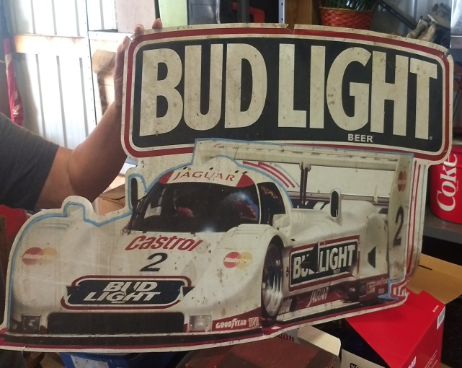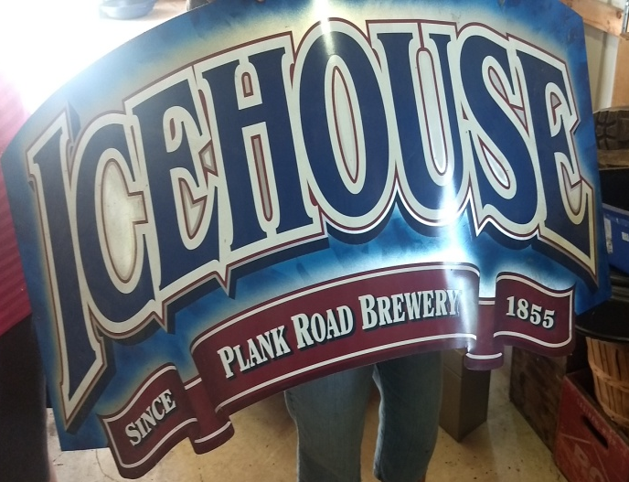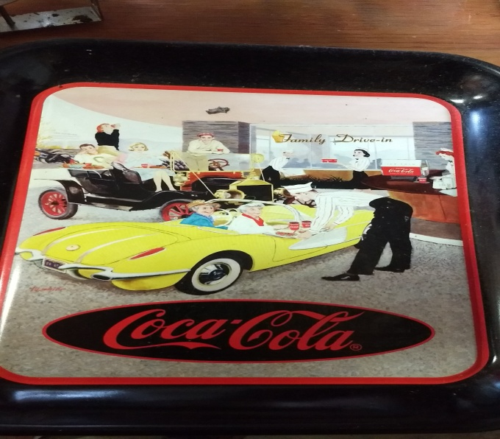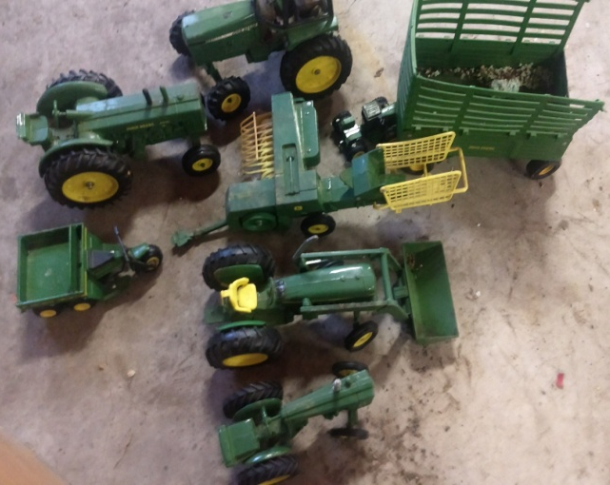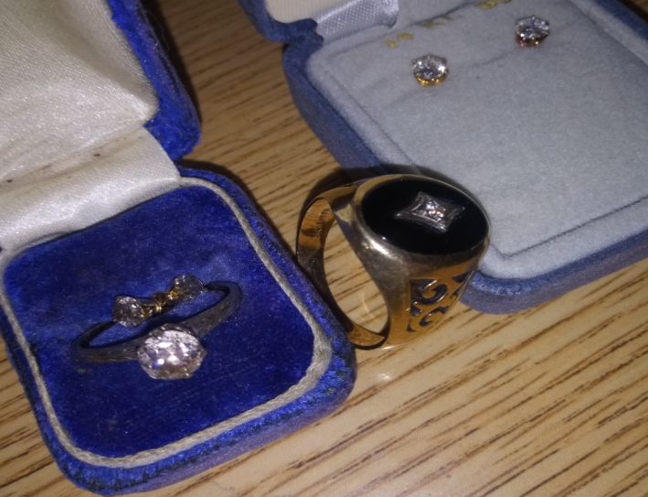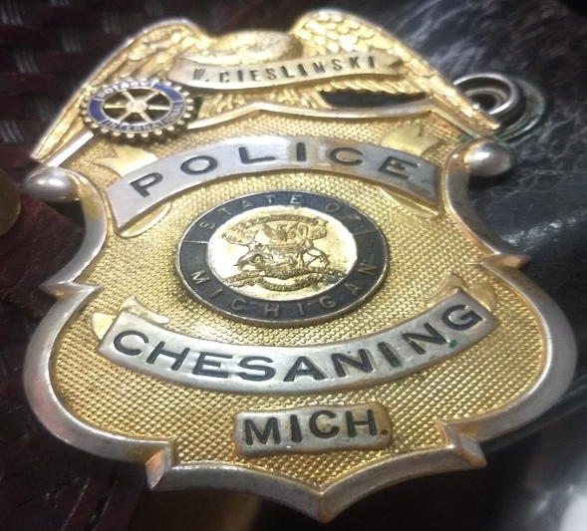
Terms & Conditions
Cash, Visa, Master, Discover (4% charge) or good Michigan check w/ proper I.D. All goods sold as-is, with no guarantees or warranties. Sales force acting as agents only and are not responsible for accidents or goods after sold. Nothing removed until settled for. Announcements made day of sale take precedence over printed matter.

