Spectacular Collectors Sale
1140 E. Burt Rd, Burt, MI 48417
August 25th 2019 @ 10 A.M.
Directions: Head southeast on I-75, Take Exit 144 towards Dixie highway, Turn right onto Dixie Highway, Turn left onto Fayette/Fort road, Turn right onto East Curtis road, Turn left onto Sheridan road, Turn left onto East Burt road
Featured Items
! Animal Head Trophies/ Fishing Trophies!
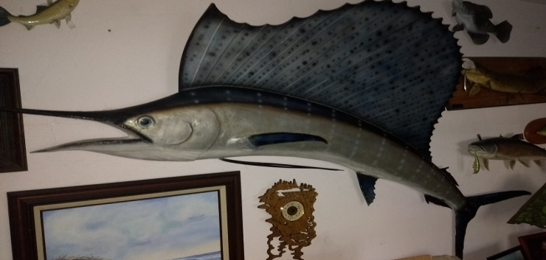
Bikes: Schwinn Corona w/ Collapsible side Baskets & Strobe Lights
Tools: Home life Generator LR4440 New; Champion Generator w/ Car Charger Attachment; 12” w/ Double Bevel w/ laser Saw, Air Compressor Double Tank; Trades Pro 2HP, Single Tank, Delta Bench Saw, Saw Horses, Extension Ladder, Gas Cans, Reddy Heater, Saw Sharpener
Automobile: Chevy Metro (150,000 Miles) Needs Work!
Yard Items: Metal Cart, Snow Blower, Weedwacker (2), Water Fountain w/ pump; Water Fountain (no pump) 2, Ram Cement Statue Troybilt Lawnmower; Assortment Yard Tools
Guns: 410 Tamer, 20 Gauge Super
Electronics: Pay Phone, Blimpie Neon Sign, Used Cars Neon Sign (needs repairs), Strobe Light, Right Or Left Handed Black/White Malibu Guitar by Greg Bennet w/ cable and amp
Hunting/ Fishing Trophies: Sword Fish 11 feet long, Boar Head, Sheep head, Goat Head, Deer Heads
Collectables: John Mellencamp Guitar (Autographed), 1879 Charles Dickens Collection
Furniture: Doctor Choice Mattress ( Brand New ) English Cabinet from Brookfield Prior Rd. Old England
Receiver Art: Picture of Elephant
Miscellaneous: Duck Decoys Display Cases, Champion Out Board Motor, Firewood, Deer Mover, Child Sled Yankee Clipper, Cabinet, 4 Gallon Beer Stein, Keurig Coffee Maker, Roosters, Water pump

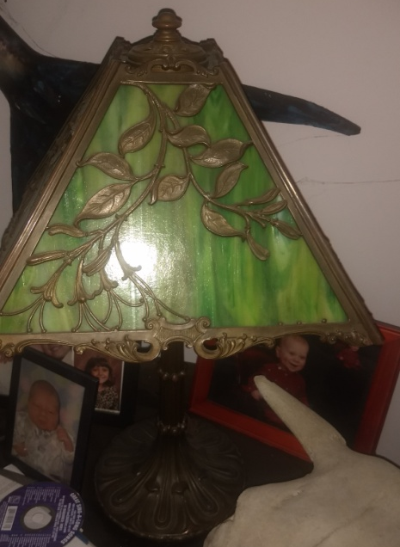
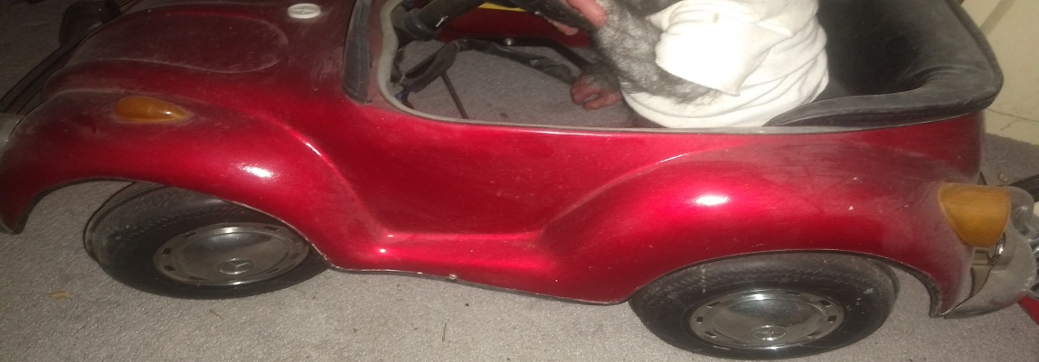
Terms & Conditions
Cash, Visa, Master, Discover (3% charge) or good Michigan check w/ proper I.D. All goods sold as-is, with no guarantees or warranties. Sales force acting as agents only and are not responsible for accidents or goods after sold. Nothing removed until settled for. Announcements made day of sale take precedence over printed matter.

