Auction of Heidi Zanan
November 10th @ 10AM
Address: 5375 Heritage, Saginaw, MI 48603
Directions: North Center Rd take Left onto Shattuck, Turn Right onto Mannion, Turn Right onto Heritage Drive
!LOOK FOR BUTLER AUCTION SIGNS!
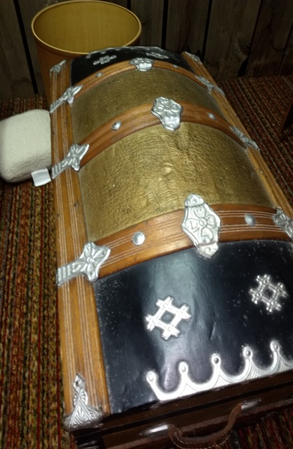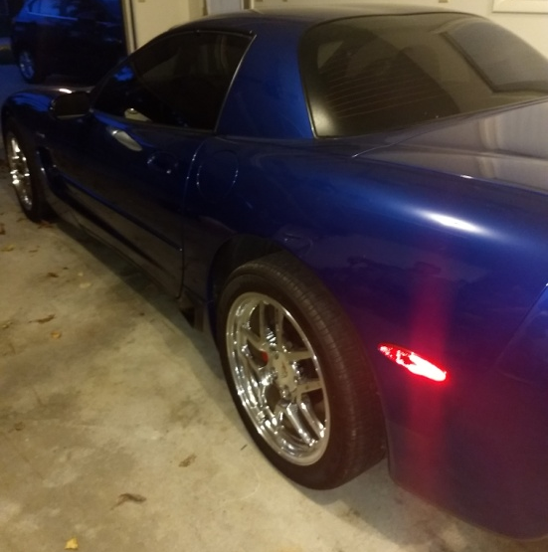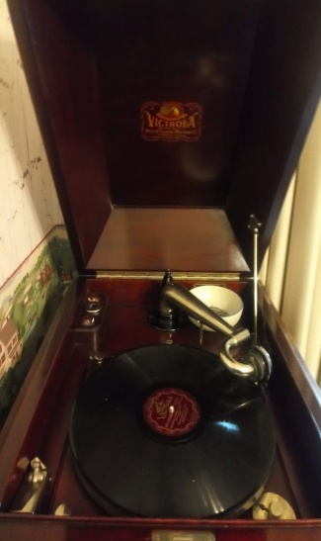
Humpback Trunk 2004 Corvette Victrola Record Player
Following Listed Items
Automobiles: 2002 Corvette, 26,021 miles
Furniture: 4 barrel back bar stools, touch lamp, Lazy Boy Recliner, Curio Cabinet, California King Bed, Dressers, Wrought Iron Lamp, Couch, Love Seat Childs Bench, School Desk, Twin Bed, Quilt Table, Vintage Trunk, Oak Table w. 6 Chairs, China Cabinet
Exercise/ Sports Items: Magnum Receive Bow 47, Free Weights, Fishing Poles, Bike Wildwood Diamond back Aluminum Frame, Budweiser Dart Board
Yard Items: Electric Grill, Miscellaneous Yard Tools, Lawnmower, CR2450 Toro Snow blower, Wagon Wheels, Fire pit, Push mower
Appliance: Top Load Maytag Washer Barley Used, Maytag Neptune Dryer
Electronics: Vintage Radio, Thomas Radio, Mantle Clock, Victoria record Player w/ Albums, Master belt electric Smokehouse. West minister Chime Clock Company
Tools: House jacks 1 ½ ton Portable Lift, Master horse Compound Miter Saw, Power Cable Saw, Ames Wheelbarrow, Craftsman 12” Two Speed Band saw 1 ½ HP, Assortment of Hand tools, Stanley Levels, Duel Halogen Lights, Mecklenburg-Duncan T Square, Master force Drill Press #3, Zip Router
Kitchen Items: Fiesta ware, Christmas Dish Set, Crockpot, Roasters, West bend Stir Crazy Popcorn Maker, Cutco Knife Set w/ holder ( Missing Steak Knives ), Pyrex French White Casserole Dishes, Eating Utensils, Vintage Coffee Grinder
Collectable Items: Hummel Plates, Hummel Figurines marked made in West Germany, Signed & Numbered Print, and Pewter Plates
Miscellaneous: Quilts, Leather Coats Sizes Medium & Large, Comforter, Vintage Hand Tools, Wagon, Playskool Ride em Giraffe, Christmas Items, Bowl & Pitcher, Picture Frames, Books and Much More!

Terms & Conditions
Cash, Visa, Master, Discover (3% charge) or good Michigan check w/ proper I.D. All goods sold as-is, with no guarantees or warranties. Sales force acting as agents only and are not responsible for accidents or goods after sold. Nothing removed until settled for. Announcements made day of sale take precedence over printed matter.

