LaBelle Estate Auction
November 24th @ 10AM
Address: 8772 S Washington, Birch Run (Fosters, MI), MI 48415
Directions: Turn right onto Gratiot Rd 0.6 mi, Continue Straight onto M-46 E/ Gratiot Ave 1.1mi, Turn Right onto Stephens St 0.4mi, Continue onto Rust Ave 0.7 mi, Turn Right onto S Washington Ave 1.1 mi, Turn Left to stay on S Washington Ave 1.7 mi, Turn Right onto Sheridan Rd 5.2 mi, Continue on Saginaw St Drive to Washington St 1.1 mi.
Following Listed Items
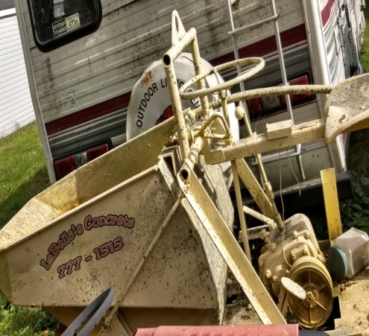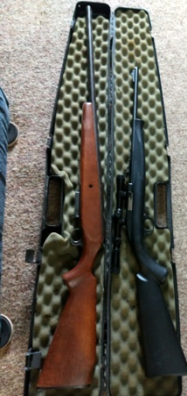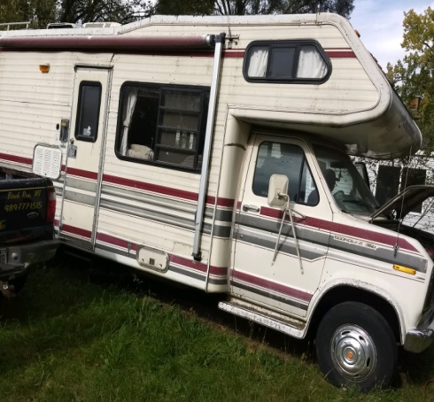Cement Dumper Guns Camper
Property: Lot w/ Garage at 8772 Washington St. Birch Run, MI 48415 ( Lots 4 & 9 BLK 2 G W Fosters Plat of Fosters also that Portion of abandoned Saginaw St lying Adjacent to SD Lots Containing Approx 0.09 Acre Sec 6 TION R5E ***Desc Changed Due to Road Abandonment Frontage 60. Depth 306 Acreage 0.421
Guns: Ammo, Winchester Single Shot 20 Gauge, Mossberg 22 Gauge w/ scope, Crossman Pellet Gun, Beretta Eureka 391 UNKE, 410 45 Caliber Made in Brazil Taurus, Mossberg 12 Gauge Bolt Action
Mobility Aids: U Step Walker, Amigo, Big Mans Wheelchair, Also an Amigo For parts
Bikes: 1946 Monarch, 1957 Monarch, Huffy 2 Person Bike, All Pro Bike
Automobiles: 2001 Ford, 1997 Dodge Pickup, Dump Truck, Coachman Travel Home (Sleeps 6), Suzuki Quad runner
Tools: Western Mortar Mixer, on wheels Gas Driven Honda Engine, 10 HP Hohler Engine Generator, 5 HP Briggs & Straiten Motor, Ladder Rack, Back Blade 3 Point, Loader trailer, Wheelbarrows, Engine Stand, Trash Pump, Power Washer, Scaffolding, 20 mm Drill Press 16 speed Floor Model, Floor Jacks, Cement Sand Packer Honda GX160 5.5, 8 ft Werner Ladder, Husky air Compressor, Car Creeper, Tool Boxes of Multiple Assortments, Assortment of Hand Tools, 6.5 HP Power Washer 20 Gallon, Car Jacks, Sears Craftsman Wet Dry Vac 3.0 HP, Bubble Tire Balancer, Laser Level Spectrum Precision, Cement Mixer, Walk Behind Concrete Cutter, Chop saw, 10 inch Table saw, Truck Tool Boxes, Concrete Dumper, Dewalt Angle Grinder, Bosch Hammer Drill, Levels
Miscellaneous: Chainsaw Blades, Multiple Belts, Coleman Lanterns, Coleman Heaters, Leaf Blower, Weber Grill, Chin mare, Flat Bottom Aluminum Boat, Antique Kerosene Stove, Fighter, Pilot Helmet, Yard Machine 18.5 HP 42” Automatic Transmission Hydrostatic Drive, Star craft Boat w/ EZ Loader Trailer, 2 Place Snowmobile Trailer, 7.5 HP no lower Unit, Boat Motor, Poulan Weed Wacker, Barrel Stove, Caribou Horns, Tractor Wheel, Bobcat
!LOTS OF SCRAP AND TOOLS!
!SOME GREAT STUFF FOR REFRABICATING!
Terms & Conditions
Cash, Visa, Master, Discover (3% charge) or good Michigan check w/ proper I.D. All goods sold as-is, with no guarantees or warranties. Sales force acting as agents only and are not responsible for accidents or goods after sold. Nothing removed until settled for. Announcements made day of sale take precedence over printed matter.

