January 5th Consignment Sale at the Saginaw Masonic Temple
@ 10AM
Address: 2655 N Center Rd, Saginaw, MI 48603
Directions: Take M84 from Bay City South to Tittabawassee, Go East on Tittabawassee, Then go South on Center

Following Listed Items
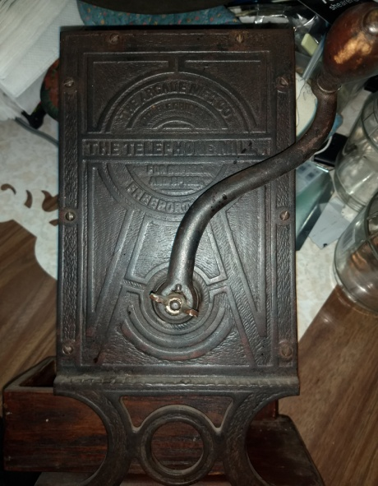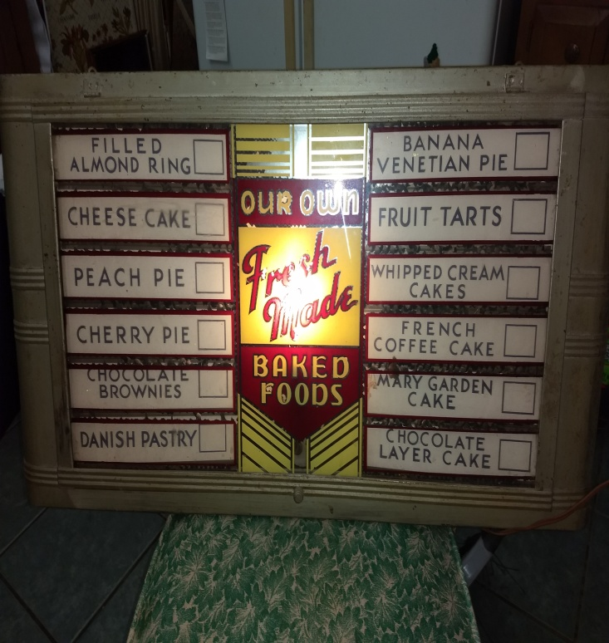
Arcade Telephone Coffee Grinder Pigeon MI Bakery Menu Sign
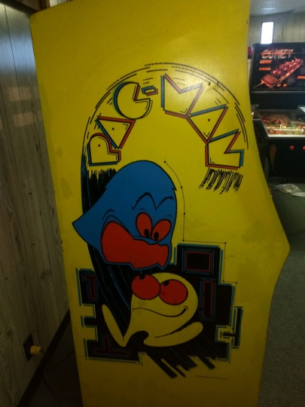
Pac Man Arcade Game 1980 Gibson
Collectables: Vintage License Plates 1912/1913, Japanese Doll under glass, Printer (late 1800’s or early 1900’s), Arcade Telephone Coffee Grinder, Menu Board from Bakery in Pigeon Michigan, Walking cane w/ hidden flask, Cast Iron Trick Dog Bank (reproduction), Indian Bird Point Arrowheads, Toby Mugs, Kelly Miller Circus Poster (2), Wood Coke Case w/ Bottles, Tobacco Tin, Multiple Longaberger Baskets, German Humpback Trunk, Box of Zinc Lid Jars, Half Pint Milk Bottles, Quart Milk Bottles, Box of Outdoor Life and Sport afield 1930’s/1940’s Magazines, Autographed Shirt by Bowzer
Crocks: Western Stoneware, Johnson made preserves, Michigan Cottage Cheese Company, Salzman Company, Cream Colored, Brown Jugs, Yellow & Tan Crock, Brown & Cream Jug w/ Handle
Arcade/Pinball Machines: Original 1980 Pac Man Arcade Game (top notch condition), Picture tube like new, Midway MFG, 1974 one Player “Skylab” nice condition
Guns: 32 Special Winchester SN 2048354 w/ weaver scope & Williams peep sight, Winchester Model 12, 12 Gauge pump SN 1259133 (mint condition), New England 2 Barrel Single Shot, One Barrel is a 22 Caliber & One Barrel is a 410, Browning Auto Five 12G, 2 ¾ SN G4458, Connecticut Valley Stacker 50 Caliber w/ Scope SN 814246, QTY 6 Henry Rifle Model H001 (22 lever action unfired)
Military Items: Bayonet w/ scabbard made in France, # 14553/Z156812 Lt Etienne M, 1873 Total Length 28 inches, Gas Mask, Hats, WWII Nazi Badges, US Army Caps (Woman’s), Instructors, Enlisted Mans, WWII Framed Pictures of Submarines (4), Dagger, (2) Swords
Advertising: Sani Seal Wooden Box
Vintage Clothing: Dresses, Pantsuits, Furs, Purses, Bolo Ties w/ precious stones, Belt Buckles
Jewelry: Silver, Sterling, Costume, 14kt gold pendant, Mass Selection of Jewelry Boxes
Coins/Stamps: Currency, Mercury Dimes, Roosevelt Dimes, Wheat Pennies, Indian Head Pennies, Ike Dollar, Silver Quarters, Walking Liberty Half Dollars, Benjamin Franklin Half Dollars, Foreign Coins, Canadian Currency, Book of Stamps, and other foreign Currencies
Emmett Kelly Jr Items: including paintings, Flyers, Statues, many signed.
Sporting Goods: Fishing Rods, Dow Shrade Knife, Bike, Duck Decoys, 10 point Deer Head, 9 Point Deer Head
Musical Equipment/ Materials: Concertina, Gibson w/ Fiber Glassed back 1980 (?), Amp, Indian Drum, Record Albums
Furniture: Glass top end tables, bedroom sets, Hope chest
Household: Carved Wooden Statues of Men & African Culture, Ceramic Mice, Ceramic Ma & Pa, ceramic Black & White Horses, Antique Family Portrait, Landscape Picture, Indian Chief Picture, Indian on Horse Picture, Dream Catcher, Red Candle Holder, Saddle Lamp, Fish Shelf
Arts/Crafts: Numerous portable Vintage Sewing Machines
Linens: Dollies, Table Cloths, Napkins, Curtains
Porcelain Dolls: Numerous to choose from, Princess Diana etc.
Post Cards: Early 1900’s, Halloween, Easter, Christmas, Location
Kitchen Household: Spice Rack, Pyrex, Kitchen Utensils, Silverware, Bowls, Roaster, Honey Holder, Garlic Holder
Books: The Gunfighters, Walking Sticks
Holiday Items: Halloween Toy Noise Makers, Ceramic Santa’s, Dickens Christmas Village Pieces
Tools: Various Tools
(Bring Your Trucks & Trailers, Lots of Parking, And more Items Than are Listed)
Terms & Conditions
Cash, Visa, Master, Discover (4% charge) or good Michigan check w/ proper I.D. All goods sold as-is, with no guarantees or warranties. Sales force acting as agents only and are not responsible for accidents or goods after sold. Nothing removed until settled for. Announcements made day of sale take precedence over printed matter.

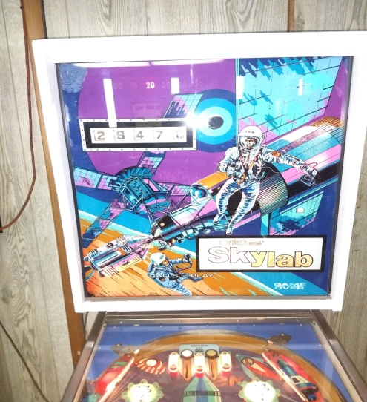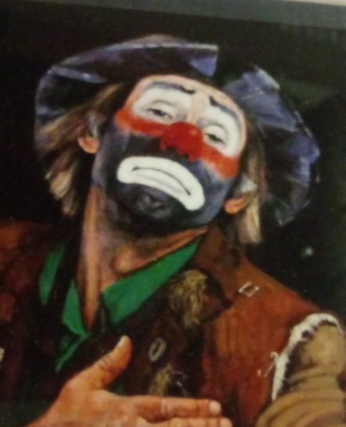
Sky Lab Pin Ball Machine Emett Kelly
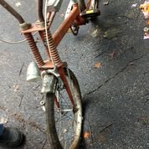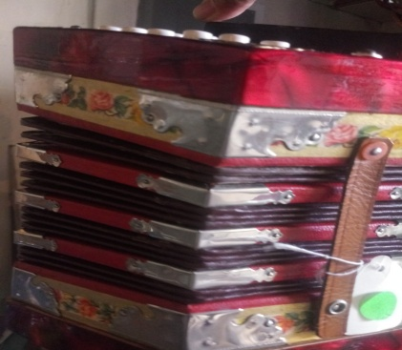
Bike Concertina
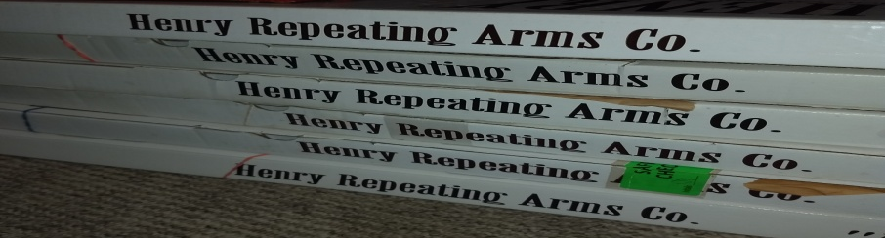
Henry Repeating Arms Co.

