William Lafevre Auction
July 24th @ 10AM
Address: 2745 N Huron Rd ( M13 ), Pinconning MI, 48650
Directions: Located near Mr. Chips, watch for auction sign
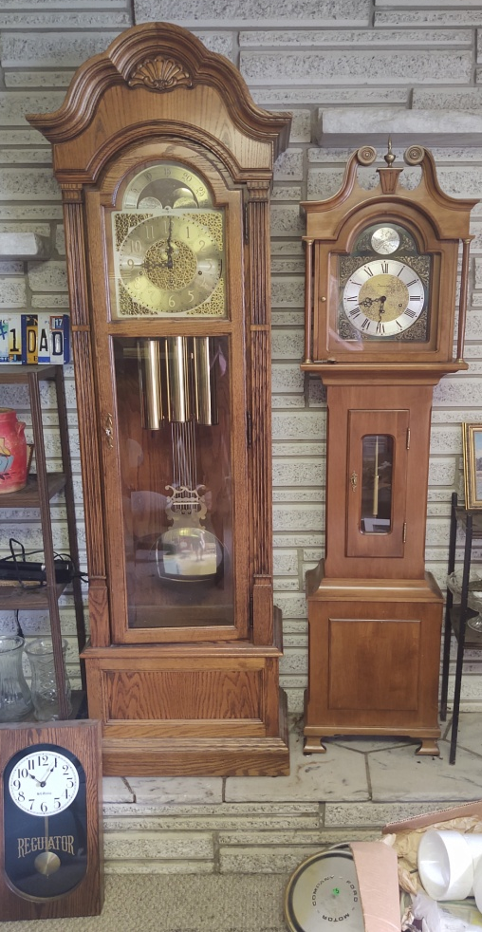
Listing:
Furniture: Red Library Chair, Magazine Stand, White Cloth Chair, 2 Basket Tables, Platform Rocker, Nautical Foot Stool, Square Glass Table, Claw Foot Table, Green Recliner, Blue Recliner, Glass top Table, Book cases, Curio Cabinets, End table w/ carved feet, Oval table w/ carved legs, Crosley Record Player AM/FM/CD/Cassette, Jwin CD Cassette Player w/ Speakers, Dressers, Night stand, Side Table, 2 Cloth seat Chairs, Cloth seat Platform Rocker, Dining Room Table w/ 4 chairs, Red Velvet chair, 2 Tier Round Table, Oak Plant Stand, Marble top Table, Small Desk, Tree Limb Footstool w/ pelt, Child's Rocking chair, Drop leaf table w/ drawer
Collectibles: Clay Cookie Jar, Cast Iron Barrel Wagon w/ horses, Bronze Pheasant, Pewter Gladiator Figurine, Charlie Weaver, Stained Glass Window, Light up UPS Sign, Salem Radio, Paulaner Munchkin Mirror, Light up Nautical Port hole, Captains Brass Bell, Statue of David, Statue of Women, Poor Boy Statue, Dragon ware, Autographed Statue of Led Gold, Oriental Vases, Oriental Hanging Lamp. Goebel Beer Sign,
Artwork: Oriental Shell Landscape, Duck Prints, James McNeill Whistler -Ship Print (From Freer Gallery of Art ), 2002 American Indian Art, Bay City Center Avenue, Portrait J. Kast, RR Photos- Pullman MI Central- Framed, Remington Prints, Copper native am art, many more pieces of artwork will be sold as well.
Outdoor: Cement Indian, Cement man, Cement Musk, Metal Chairs, Cement Frog, Frog w/ ducks, Outdoor Furniture, Grill
Misc: Black Light, Pottery, Fan, Heater, lamps, Alto loud speaker system, Cat figurine
Store Furniture: Showcases (some matching).Mannequins.

Terms & Conditions
Cash, Visa, Master, Discover (4.5% charge) or good Michigan check w/ proper I.D. All goods sold as-is, with no guarantees or warranties. Sales force acting as agents only and are not responsible for accidents or goods after sold. Nothing removed until settled for. Announcements made day of sale take precedence over printed matter.
