Estate Auction of Bernard Wenzel
Sept.11th @ 10AM
7515 Dutch, Saginaw, MI 48609
Directions: Take w Gratiot to River Road, Left on River road, Right on Dutch
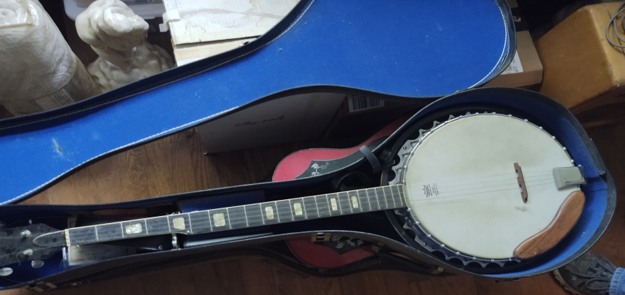
-5 string Banjo-
Following Listed Items
Books, Binoculars, 2 corner Cabinets (Identical), Clocks, Assorted Carnival, Mandolin,
Lots of Car Models, Entertainment Center, Trains, Harley Davison Ho Trains, Teddy Rux
pin, Plant Stand, Winnie The Pooh & Fox and the Hound (in boxes), Sewing Machines,
Quilts, Lamps, Banjo (5 String), Violin, Guitars, SNAP ON Toll Box, Tools,
Craftsman Toolbox, Medal Wagon Wheels, Kettle, Gravity Zero Turn, Tires w/ Rims
Lots, Wringer Washer, Lawn Equipment, Car Hoist, Curio Cabinets, Gas Grill, Vintage
Games, Kiln, Lawn Ornaments, Lots of scrap, and much more!
Guns: Winchester 22 & 12 Gage Pump Mossberg, 410 bolt Action, Daisy BB Gun
Motor Vehicles: 1985 Harley Davison Motorcycle #1HDIDDL17FY501853, Snow Mobiles, 4 Gas Golf Carts, Boats, 300
International Tractor w/ Blade, Farmall C Tractor, Pontoon
Terms & Conditions
Cash, Visa, Master, Discover (4.5% charge) or good Michigan check w/ proper I.D. All goods sold as-is, with no guarantees or warranties. Sales force acting as agents only and are not responsible for accidents or goods after sold. Nothing removed until settled for. Announcements made day of sale take precedence over printed matter.


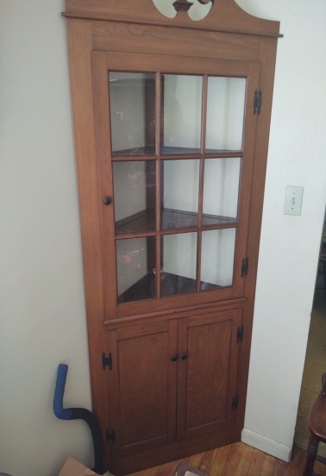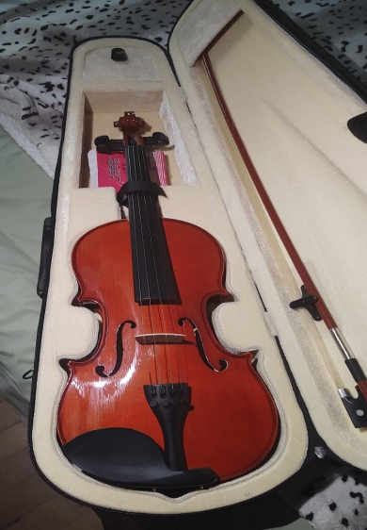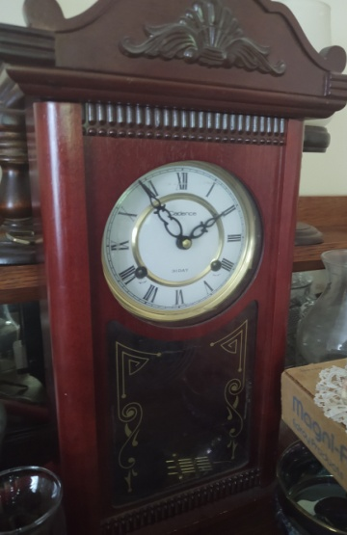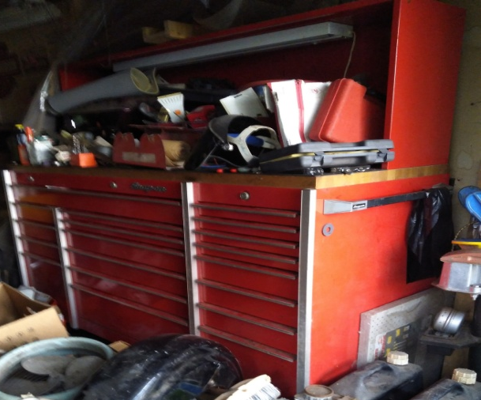
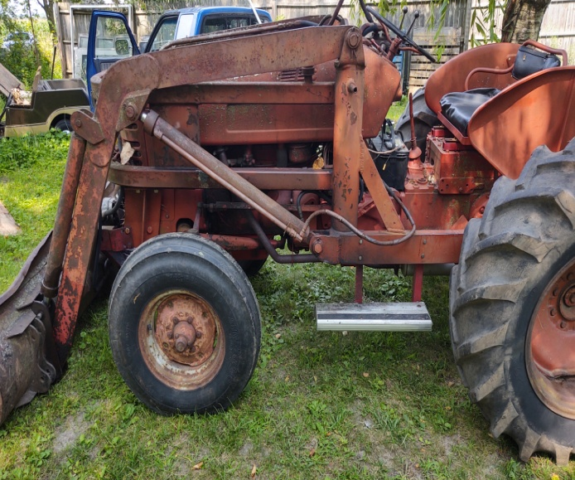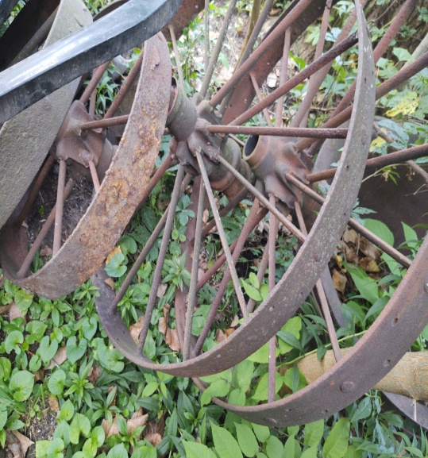

Fod and Restroom Available.
Terms: Cash, Visa, Master, Discover ($50. min) or good Michigan Check w/proper I.D. All goods sold as-is, with no guarantees or warranties. Sales force acting as agents only and are not responsible for accidents or goods after sold. Nothing removed until settled for. Announcements made day of sale take precedence over printed matter.

